Customer Pages

|  |  |  |  |  |  |  |  |  |  |  |  |  |  |
| --- | --- | --- | --- | --- | --- | --- | --- | --- | --- | --- | --- | --- | --- |
| Testing | Cart Pa e | | | | | |  |  | |  | |  | |
| Test ID |  | | | Field | | | Input | Expected Result | | Actual Result | | Pass or Fail | |
| 1.0 |  | | | Quantity | | | 2 | Updates quantity | | Updates quantity to 2 and the price updated too | | Pass | |
| 1.1 |  | | | Quantity | | | -1 | Set the value to 1 | | Sets the value to 1 | | Pass | |
| 1.2 |  | | | Quantity | | | 1234 | Set the value to 127 message saying low in stock | | Sets the value to 127 message saying low in stock | | Pass | |
| 1.3 |  | | | Quantity | | | -1234 | Set the value to 1 | | Sets the value to 1 | | Pass | |
| 1.4 |  | | | Quantity | | | Null | Set the value to 1 | | Sets the value to 1 | | Pass | |
| 1.5 |  | | | Quantity | | | AAAAAAAAAA,  AAAAAAAAAA | Set the value to 1 | | Sets the value to 1 | | Pass | |
| 1.6 |  | | | Quantity | | |  | Set the value to 1 | | Sets the value to 1 | | Pass | |
| 1.7 |  | | | Quantity | | | Decimal | Set the value to 1 | | Sets the value to 1 | | Pass | |
| 1.8 |  | | | Quantity | | | - Sequel inject statement | Set the value to 1 | | Sets the value to 1 | | Pass | |
| 1.9 |  | | | Quantity | | |  | Set the value to 1 | | Sets the value to 1 | | Pass | |
| Testin | | checkout | | | page |  | | |  | |  | |  |
| Test ID | |  | Field | | | Input | | | Expected Result | | Actual Result | | Pass or Fail |
| 2.0 | |  | First name | | | Special characters, numbers | | | Error message | | Error message | | Pass |
| 2.1 | |  | First name | | | -test | | | Error message | | Inserted name | | Fail |
| 2.2 | |  | First name | | | - Sequel inject statement | | | Error message | | Error message | | Pass |
| 2.3 | |  | First name | | | <script></script> | | | Error message | | Error message | | Pass |
| 2.4 | |  | First name | | | Name | | | Inserts name | | Inserted name | | Pass |
| 2.5 | |  | Last name | | | Name | | | Inserts name | | Inserted name | | Pass |
| 2.6 | |  | Last name | | | Special characters, numbers | | | Error message | | Error message | | Pass |
| 2.7 | |  | Last name | | | -test | | | Error message | | Inserted name | | Fail |

16

Function Testing

|  |  |  |  |  |  |  |  |  |  |  |  |
| --- | --- | --- | --- | --- | --- | --- | --- | --- | --- | --- | --- |
| Form functions.inc. h | |  | | |  | |  |  | |  | |
| Test | Function | | | | Input | | Expected Output | Actual Output | | Pass or Fail | |
| 1.0 | Create_form_input() | | | | $name, $type, $errors,  $values | | Generates a form Input or select tag. | Generates a form. | | Pass | |
| Product function.inc. h | | |  | | |  | | |  | |  |
| Test | Function | |  | Input | | Expected Output | | | Actual Output | |  |
| 2.0 | get_stock_status() | |  | $stock | | Nothing | | | Nothing | | Pass |
| 2.1 | get_stock_status() | |  | $stock > 5 | | 'In stock'; | | |  | |  |
| 2.2 | get_stock_status() | |  | $stock > 0 | | 'Low stock'; | | |  | |  |
| 2.3 | get_stock_status() | |  | If there are no stock left. | | 'Currently out of Stock'; | | |  | |  |
| 3.0 | get_price() | |  | $type, $regular, $sales | | Nothing | | | Nothing | | Pass |
| 3.1 | get_price() | |  | $type 'coffee' | | Add sale price if it's greater than O and less than regular price.  return ' Sale: $ 1 . $sales . | | |  | |  |
| 3.2 | get_price() | |  | $type == 'goodies' | | Display sale price if it's greater than O and less than regular price. return "<strong>Sale Price:</strong> \$$sales! (normally \$$regular)<br | | |  | |  |
| 4.0 | get_just_price() | |  | $regular, $sales | | Nothing | | | Nothing | |  |
| 4.1 | get-just_price() | |  | Displays sales price when appropriate | | return number_format($sales, 2); | | |  | |  |
| 4.2 | get-just_price() | |  | Displays sales price when appropriate | | return number_format($regular, 2); | | |  | |  |
| 5.0 | parse_sku() | |  | $sku | | Returns the values $sp_type, $pid | | | Returns the values $sp_type,  $pid | | Pass |
| 6.0 | get_shipping() | |  | $total=O | | Nothing | | | Nothing | | Pass |
| 6.1 | get_shipping() | |  | 100 | | return number_format($shipping,  2); | | | Returns the shipping total | |  |

3.3.2 Blackbox Testing

14

|  |  |  |  |  |  |  |
| --- | --- | --- | --- | --- | --- | --- |
| Cart. h | |  |  |  |  |  |
| Lin | Condition | | If True | Else | Notes | Pass or  Fail |
| 9 |  | | $uid = | $uid = md5(uniqidCbi pedl,true)); | Checks for and creates a user session. | Pass |
| 30 | (isset($_GET['sku'])) | | list($sp_type, $pid) = parse_sku($_GET['sku']); | Nothing | Breaks sku value in the URL into parts. | Pass |
| 34 | (isset ($pid, $sp_type,  'add') ) | | $r = mysqli_query($dbc,  "CALL  I $sp_type l, $pid, 1)"); | elseif (isset ($sp_type,  $pid,  $_GET['action']    ] Iremove') ) | Adds a new product to the cart by  or removes the product from the cart. | Pass |
| 38 | Else if | | (isset ($pid, $sp_type,  'add') ) If the condition above is true the product is added to the cart. | (isset  ($sp_type,  $pid,  'move')  )  ] | This else if statement moves the product to the cart. | Pass |
| 50 | Else if | | (isset ($pid, $sp_type,  add') ) If the condition above is true the product is added to the cart. | quantity'])) | This else if statement updates the quantities of the cart. | Pass |
| 62 | (mysqli_num_rows($r) > O) | | Include  ('./views/cart.html'); | include  ('./views/empt ycart.html'); | Displays two different html pages based on if there are cart contents. | Pass |

5

Cart Page:

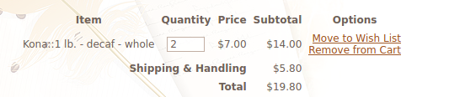

Testing 1.0

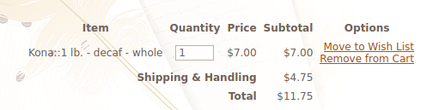

Testing 1.1

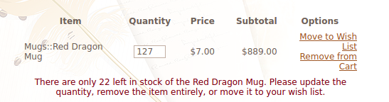

Testing 1.2

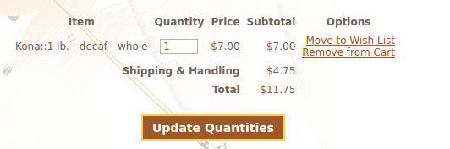

Testing 1.3

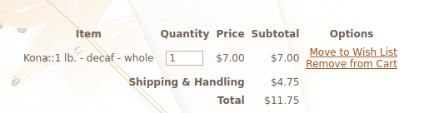

Testing 1.4



Testing 1.5

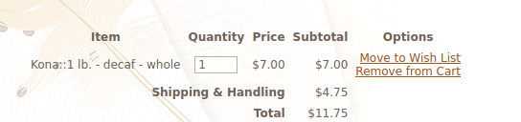

Testing 1.6

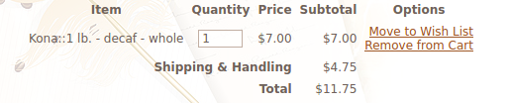

Testing 1.7

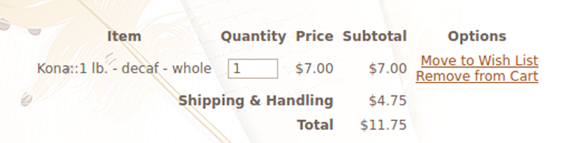

Testing 1.8

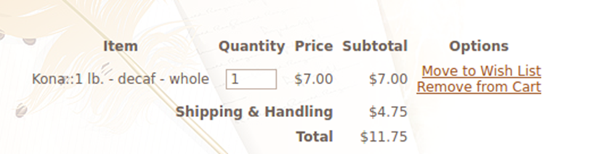

Testing 1.9

**Checkout page**